**PROJECT DESIGN PHASE-II**

**FUNCTIONAL REQUIREMENTS DOCUMENT**

|  |  |
| --- | --- |
| Date | 08 October 2022 |
| Team Lead | E.A.Hyagiriva |
| Team Members | Ashraf Ali.S  Keerthi.K.M  G.S.Nikkila |
| Project Name | Car Resale Value Prediction using Machine Learning |

1. **GENERAL**
   1. **PROBLEM STATEMENT**

Car resale value prediction is very important in this modern period where everyone owns a car.Many people are ready to sell their cars once they find a new model or once their car gets old. But the problem Is that they do not know the exact price of their car. Many just approximately quote a price and they just complete a deal, it is either a loss for the seller or a loss for the buyer. This model brings a solution to it, this model helps in predicting the exact or the most appropriate price for the vehicle so that it is not a loss for the seller as well as the buyer

* 1. **PROPOSED SOLUTION**

Almost all the existing car details and their most common type of selling details are stored in a csv format. This data is then loaded, preprocessed in order to remove null values, segregate the dependent and independent variables, encode the needed columns, create analysis maps, split the data into training and testing data, choose the model which can suit this problem, train the model with the training data, test the accuracy with the test data against predicted data and save the model to integrate it with a web app. A web app is built which renders a form for the user to enter the attributes.The saved model is loaded and the entered values are fed into the loaded model and the predicted results are returned to the user. The model is then deployed into the cloud for the web app to request from the deployed model.

1. **CONTEXT DIAGRAM**

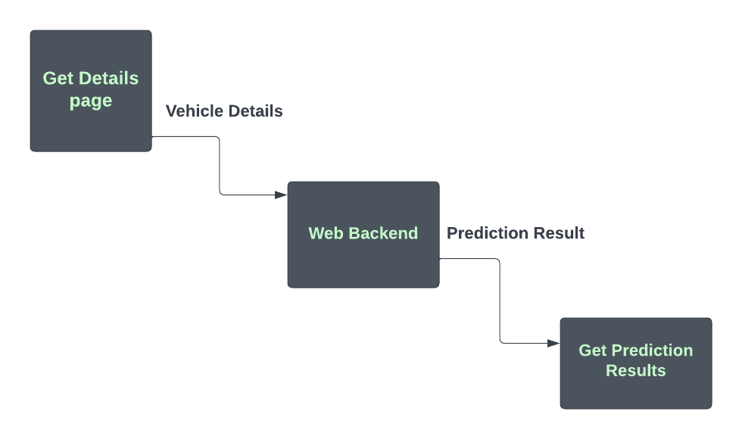

1. **DATA FLOW DIAGRAM**

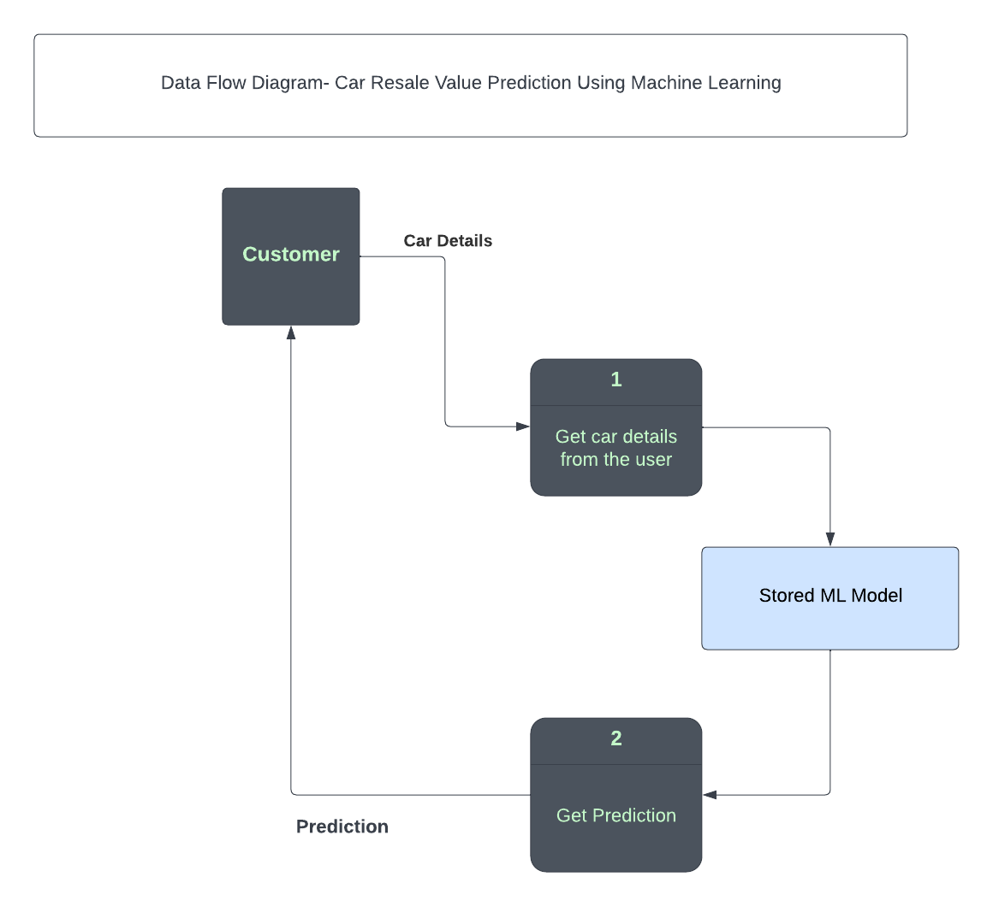

1. **FUNCTIONAL REQUIREMENTS**

|  |  |
| --- | --- |
| **REQUIREMENT ID** | **REQUIREMENT DESCRIPTION** |
| 1 | Users should be able to see the options in which they enter the car details such as kilometers driven, engine condition etc when they enter the home URL. |
| 2 | Users should select all the details with all the necessary attributes filled and should be appropriately notified when some values are missing. |
| 3 | The app should accept the test values and feed those inputs into the pre-saved trained machine learning model and should return the prediction result. |
| 4 | The app should redirect the users to the appropriate page based on the prediction result. |